Thomas Kennedy Sampson & Tompkins LLP

Founded in 1971, Thomas Kennedy Sampson & Tompkins LLP is the oldest African American owned law firm in Georgia. The firm serves the legal needs of Fortune 500 corporations, governmental authorities, and small businesses. Thomas Kennedy Sampson & Tompkins LLP is rated a v by Martindale-Hubbell (the highest rating possible) and is listed in the Bar Register of Preeminent Lawyers, published by Martindale-Hubbell. The firm is listed in the Best Lawyers in America and has been recognized in the National Law Journal’s feature Who Represents Corporate America and in Corporate Counsel magazine’s feature Who Represents America’s Biggest Companies.

Civil Trial Practice • Commercial Litigation • Employment Law
Products Liability • Medical Malpractice • Premises Liability
Arbitration/Mediation • Insurance Defense
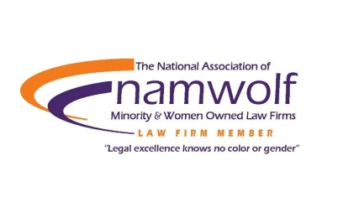
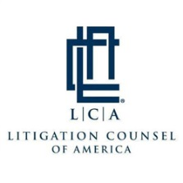

Atlanta, Georgia
www.tkstlaw.com • (404) 688-4503
_______________________________________________________

